Steps to create the SDG project

1. Python -m venv ven //Create a virtual environment
2. Ven/Scripts/activate // Activate the virtual environment
3. Pip install django // Install Django
4. Django-admin startproject SDGs // Creates a project
5. Cd SDGs //change into the project directory
6. Django-admin startapp SDG //creates a app in the project
7. Python manage.py migrate //migrates required files for the app
8. Python manage.py runserver //check if the Django installation is working

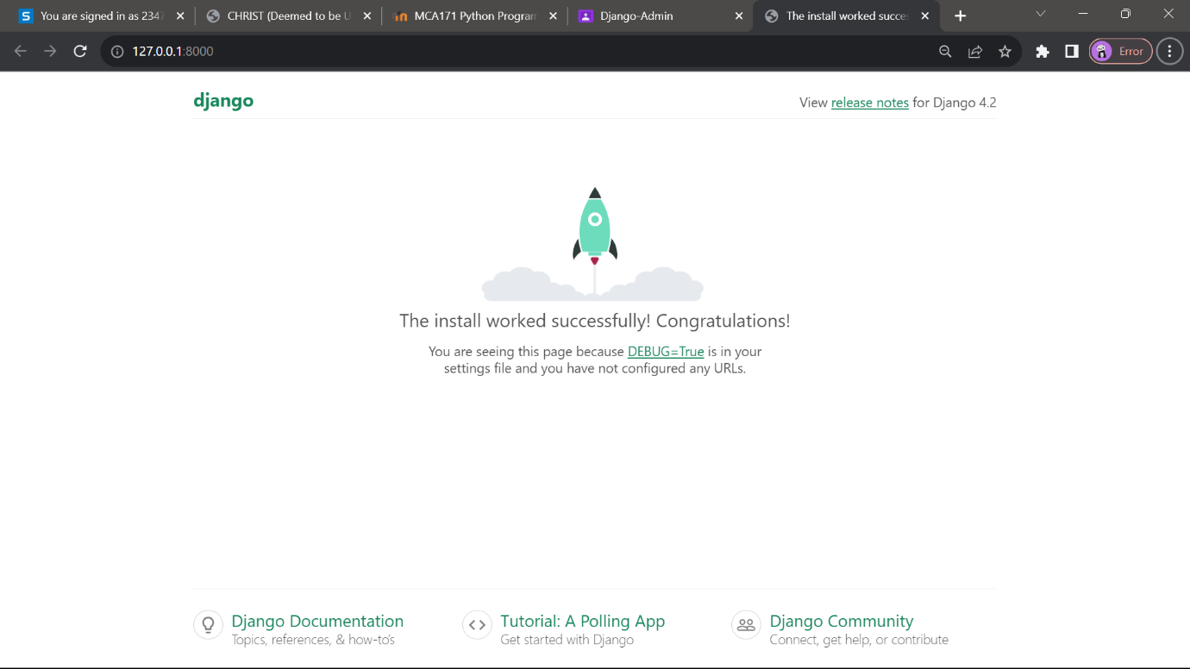

Creating and running the html files:

1. Create a templates folder in the app and post all the html files in it

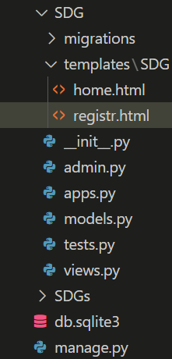

1. Modify view.py

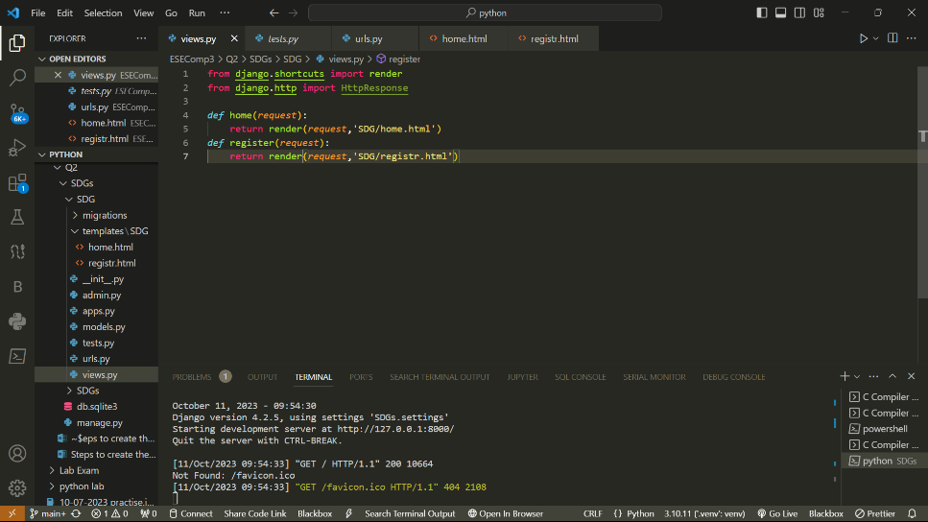

1. Create urls.py in SDG folder and modify it

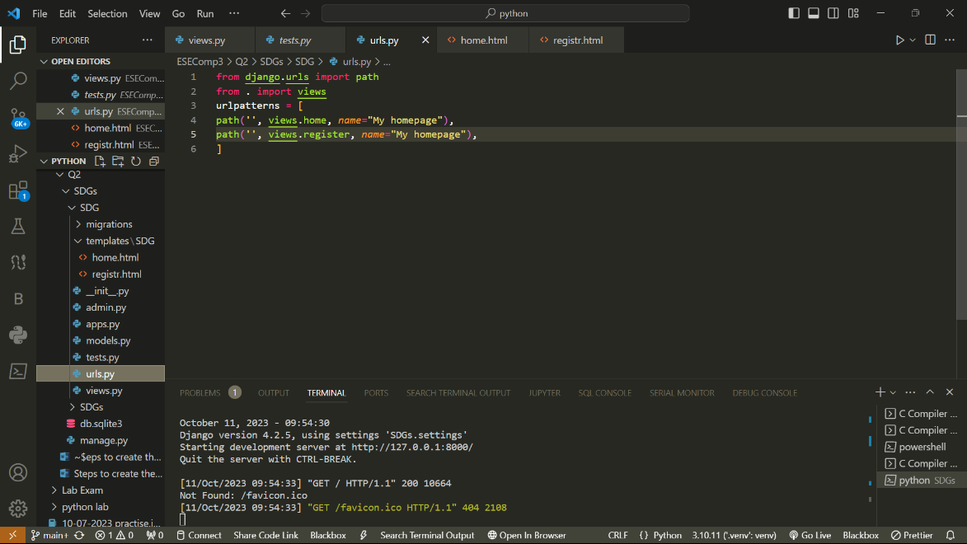

1. Go to setting.py and add SDG app

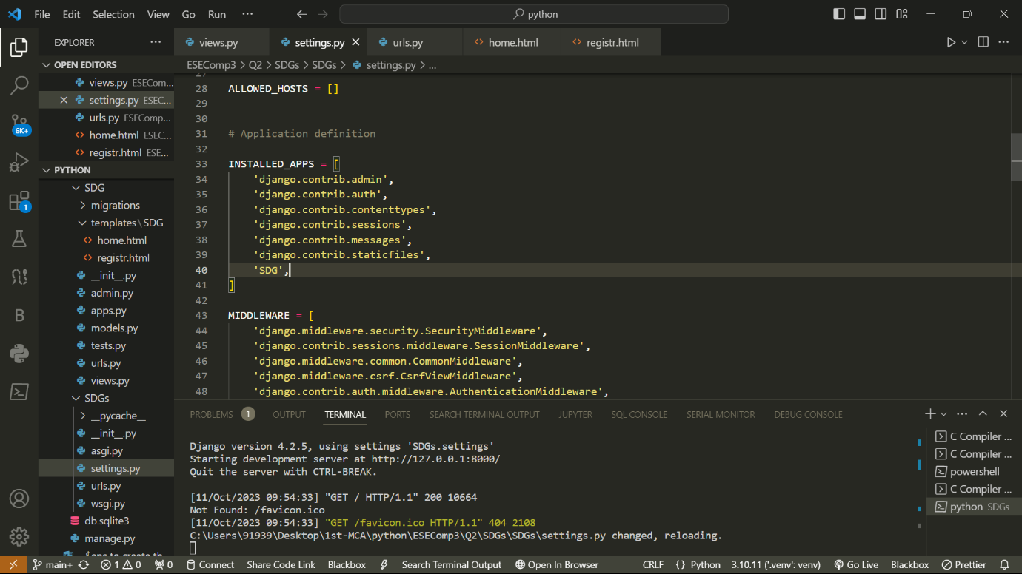

1. Modify the urls.py in SDGs project

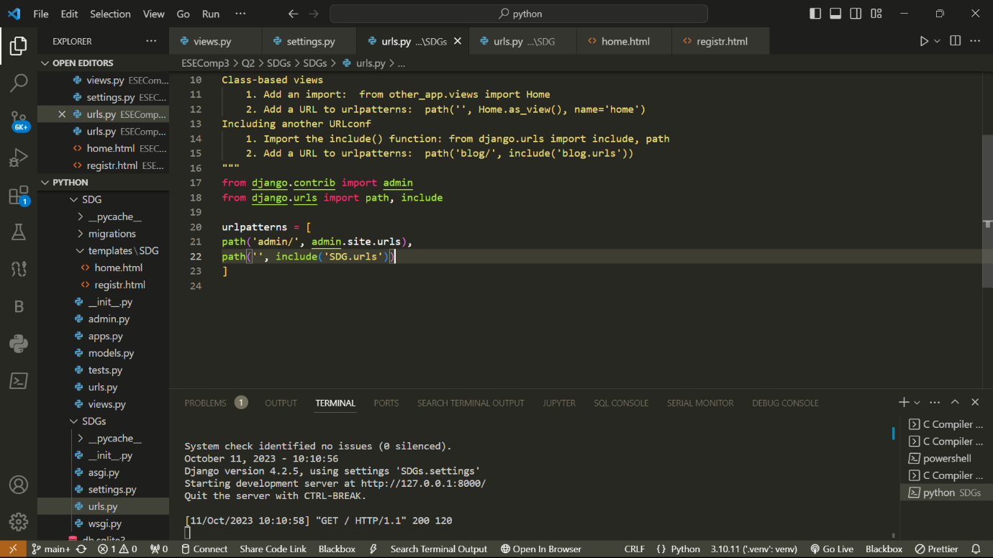

Creating a superuser

1. python manage.py createsuperuser

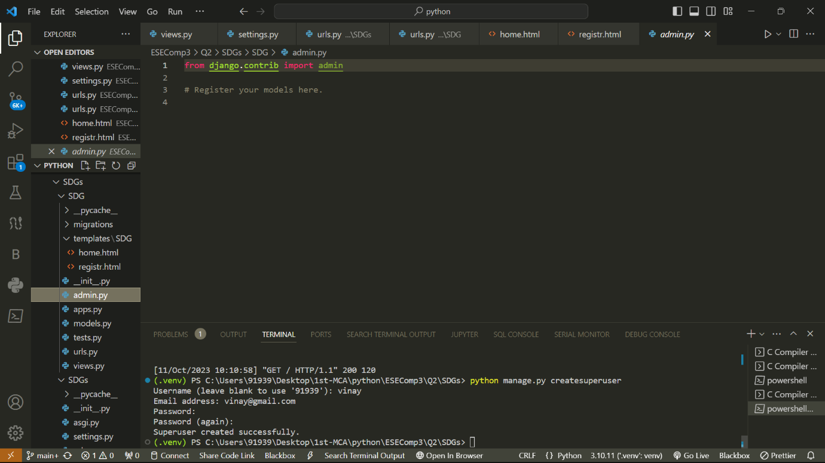

1. Open the server with the /admin path and do the required operations of adding and removing the users or groups

